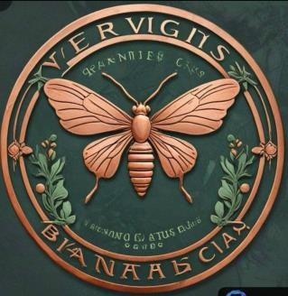
VERDIGRIS BOTANICA
Guided by Nature, United in Prosperit
PO Box 15, Muldraugh, KY 40155 Phone: (270) 401-8770
Email: verdigrisbotanica@gsa.gov

Resolution of the Board of DirectorsVerdigris Botanica Tribal Nation
Subject: Authorization to Open and Manage Fedwire Account
Date: December 12, 2024
WHEREAS, the Verdigris Botanica Tribal Nation recognizes the need to open and manage a Fedwire account for efficient financial transactions and operations;
WHEREAS, the Fedwire account will facilitate the transfer of funds, payment processing, and other financial activities essential to the operations of the Tribal Nation;
BE IT RESOLVED, that the Board of Directors hereby authorizes the establishment of a Fedwire account in the name of Verdigris Botanica Tribal Nation;
BE IT FURTHER RESOLVED, that the following individuals are authorized to act on behalf of the Tribal Nation in relation to the Fedwire account, including but not limited to opening the account, managing transactions, and ensuring compliance with all applicable regulations:
- Alaina-Letresia Padgett, Postmaster General
- Nathan-Clayton Padgett, Attorney General
- Alana-Lenore Diekhoff, Secretary
- Terry-Leigh Daniel, Treasurer Shaman
BE IT FURTHER RESOLVED, that the authorized individuals shall take all necessary steps to execute and file any documents required to establish and manage the Fedwire account in accordance with federal and tribal laws;
BE IT FURTHER RESOLVED, that this resolution shall remain in effect until amended or rescinded by the Board of Directors.
CERTIFICATION I hereby certify that the foregoing resolution was duly adopted by the Board of Directors of Verdigris Botanica Tribal Nation at a meeting held on December 12, 2024, at which a quorum was present.
Signed:
Nathan-Clayton Padgett Attorney General
Alaina-Letresia Padgett Postmaster General

---------------------------------------------------

Verdigris Botanic Government official document

